EEN1095 Git Repository and Development Record
Student Name | Dhanush Kumar Ramesh | Student ID | A00013665
Project Title | Yield-Aware Inverse Design of High-Speed Interconnects: A Physics-Constrained Generative Approach | Supervisor | Dr. Marissa Condon
Implementation Period | Week 11 - Week 12 | Version Date | 30/07/2026
Link to the Repository | https://github.com/DhanushkRamesh/Generative_Inverse_Design_of_High-Speed_Interconnects | Shared to Supervisor | Yes

Guidance: Maintain this as one cumulative document throughout EEN1095. Update it every two weeks and do not remove earlier records. Use it to summarise sustained implementation and development work evidenced through your Git repository or equivalent version-controlled development record. Each entry should summarise the development work completed, the principal files or components affected, and the key evidence of progress. Where applicable, relevant screenshots of the Git commit history should also be provided.

Development Record:
Weeks 1-2
Main implementation / development work completed | Completed the data pipeline and Forward Model design
Key files, folders, or components added / updated | Added sandbox_v1 where all the updates are being made in sandbox env before moving to the main directory. Maintained in order to do ablation study and not spam the main directory.
Evidence of versioning / commits / iterations | Recent commit was the addition of Sandbox_v1 updates with the 1d cnn forward model.
Testing, debugging, or validation carried out | The data pipeline was tested to verify with the ground truth data
Problems encountered and how they were addressed
Next development steps | Design and complete a fully working inverse model and also improve the forward model for the link dataset.

Weeks 3-4
Main implementation / development work completed | Designed the baseline inverse design architecture
Key files, folders, or components added / updated | Sandbox_v1/ added where the minor changes in the forward model (limiting the frequency range to 60GHz and baseline implementation of the inverse model – and a simple architecture including the yield optimization
Evidence of versioning / commits / iterations | Worked on implementation of inverse model design (baseline arch.)
Testing, debugging, or validation carried out | Tested the model on the prediction of geometries and compared the s parameter profile with the ground truth on the geometrics predicted by the model
Problems encountered and how they were addressed | The model was not optimized and the prediction was way off the ground truth – it weas addressed by changing the loss the method of defining loss function and the yield penalty was removed initially to see how the mode performs.
Next development steps | Improvise the baseline inverse model and implement yield optimization and also include active learning loop using openEMS

Weeks 5-6
Main implementation / development work completed | EDA on the frequency range to study the importance of the regions. Improvise the inverse model by using TTO. openEMS implementation is in progress to validate the geometrics generated by the model.
Key files, folders, or components added / updated | Sandbox_v1/  https://github.com/DhanushkRamesh/Generative_Inverse_Design_of_High-Speed_Interconnects/tree/feat/rational-net/sandbox_v1
Evidence of versioning / commits / iterations | Tried new methods to improve the inverse model and performed an EDA on the frequency range to study the importance of the regions and mask the frequency range in the loss function to improve accuracy of the model. 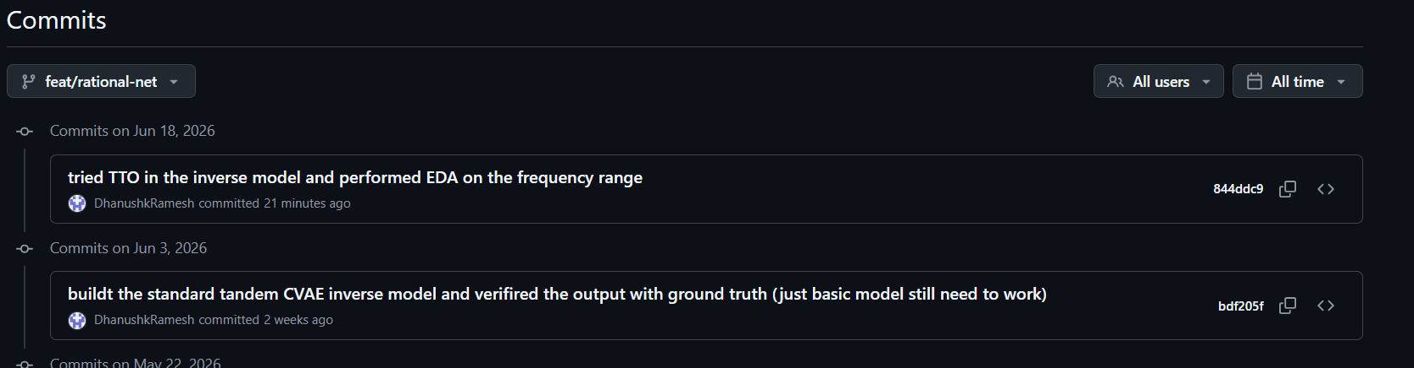
Testing, debugging, or validation carried out | Performed EDA on the frequency range to find out the weights that need to be used for the loss function and making the region accordingly to improve accuracy of the model.
Problems encountered and how they were addressed | The model was performing worse in the high freq. range and hence the deep resonance dips were averaged instead of tracking accurately. Tried to mask the frequency regions accordingly to include weight based on the frequency range in the loss function and used TTO method to improve accuracy of the model.
Next development steps | Outline the planned development tasks for the next two-week period.
Weeks 7-8
Main implementation / development work completed | Test Time optimization and openEMS Simulation
Key files, folders, or components added / updated | Sandbox_v1/ with implementation of TTO, and openEMS_sim/ with openEMS simulation to use for validation of the model output.
Evidence of versioning / commits / iterations | Working on the openEMS simulation 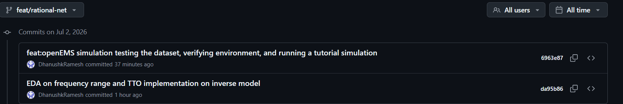
Testing, debugging, or validation carried out | openEMS validation to be done after simulation complete. Initial test simulations been tested and tutorial from official documentations being followed.
Problems encountered and how they were addressed
Next development steps | Complete the openEMS simulation and validate the results. Implement yield optimization.

Weeks 9-10
Main implementation / development work completed | Complete openEMS simulation
Key files, folders, or components added / updated | openEMS_sim/, and updated sandbox_v1/
Evidence of versioning / commits / iterations | 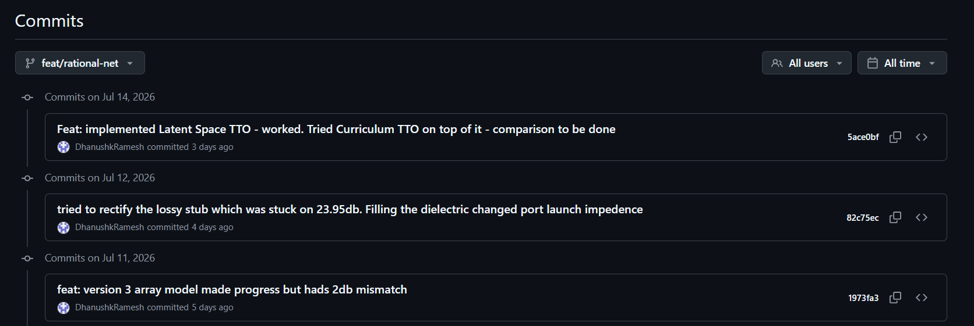
Testing, debugging, or validation carried out | Validation off openEMS simulation was carried out initially comparing it with the CONMLS sim from the TUHH database and then openEMS simulation of ground truth data and model generated data
Problems encountered and how they were addressed | Had issues with lumped ports when simulation and the simulation exploded mid-way – resolved with coaxial ports.
Next development steps | Develop latent TTO and Implement Yield Optimization to the model.
Weeks 11-12
Main implementation / development work completed | Completion of Latent space TTO (curriculum TTO) and Yield Aware TTO inverse model.
Key files, folders, or components added / updated | Added yield aware inverse model scripts in sandbox_v1/ dir.
Evidence of versioning / commits / iterations | Yield aware inverse were pushed to the git and the rational net branch was merged to the main branch. Changes to be made with main branch from now as project implementation is almost complete.  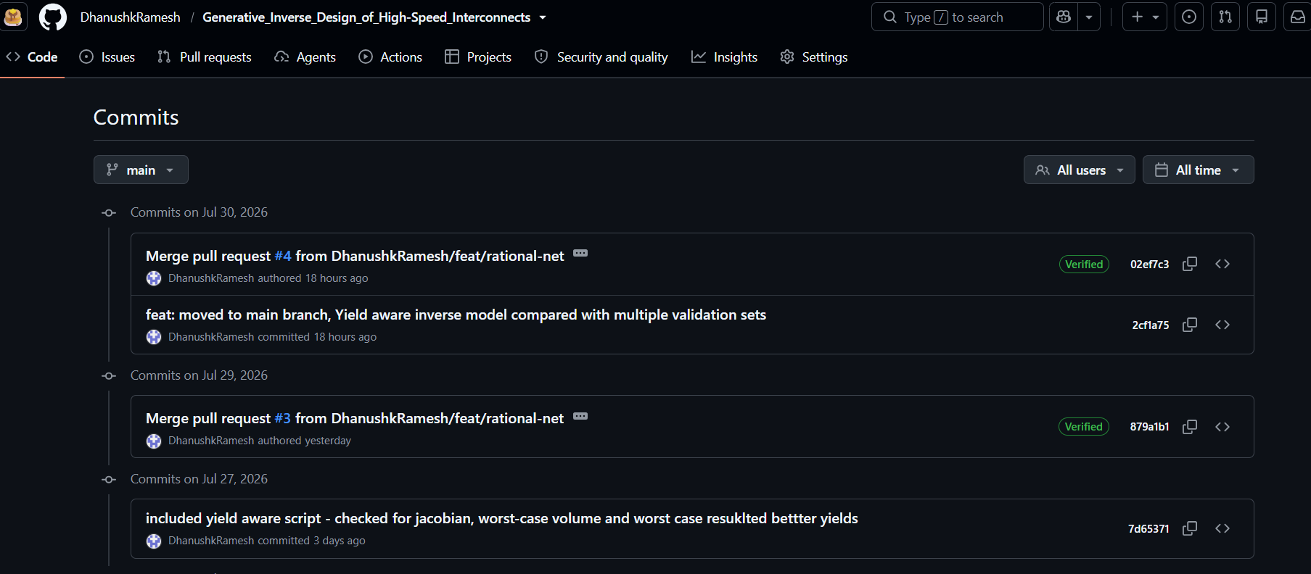
Testing, debugging, or validation carried out | Tested the yield aware inverse generated designs (geometry) produced. Need to test the openEMS simulation for the generated designs.
Problems encountered and how they were addressed | The Jacobian penalty was initially proposed to build the yield optimization, but the Jacobian reduced the sensitivity but had very little / no impact on the yield. So explored other methods and decided to go with worst case corners method for yield optimization.
Next development steps | Validation with openEMS for the generated yield aware designs.

Weeks 13-14
Main implementation / development work completed
Key files, folders, or components added / updated
Evidence of versioning / commits / iterations | Enter a short summary of commit activity here. Add commit-history screenshots if applicable.
Testing, debugging, or validation carried out
Problems encountered and how they were addressed
Next development steps | Outline the planned development tasks for the next two-week period.

